A NEW-COUPLED-INDUCTOR CIRCUIT BREAKER FOR DC APPLICATIONS
ABSTRACT
In order to eliminate power conversion steps, future microgrids with renewable energy sources are being visualized as dc power systems. System components such as sources (solar panels, fuels cells, etc.) loads, and power conversion have been identified and are readily available. However, when it comes to dc circuit breakers, many designs are still in the experimental phase. The main limitation is that interrupting a current which does not have a zero crossing will sustain an arc. This paper introduces a new type of dc circuit breaker. It uses a short conduction path between the breaker and load as well as mutual coupling to automatically and rapidly switch OFF in response to a fault. The proposed breaker also can have a crowbar type switch at the output so that it can be used as a dc switch. Mathematical analysis, detailed simulation, and laboratory measurements of the new dc switch are included.

BLOCK DIAGRAM FOR PROPOSED SYSTEM
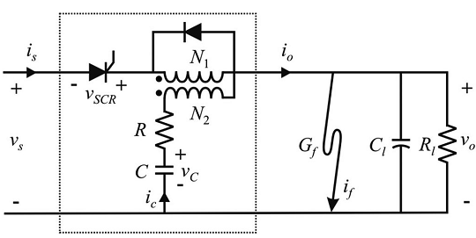
Fig. 1. Proposed dc circuit breaker.
DESIGNG SOFTWARE AND TOOLS:
MAT LAB /SIMULATION Software and simu power systems tools are used. Mainly control system tools, power electronics and electrical elements tools are used.

